PART 2

10.Make backup of your database

10.1 mysqldump -uroot -p book_Shop > book_Shop_backup.sql

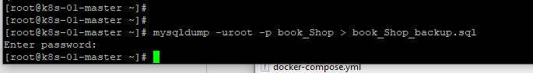

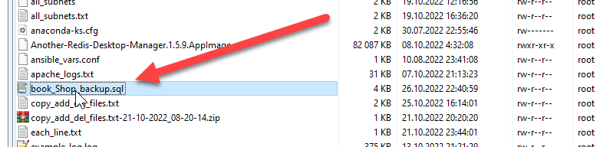

11.Delete the table and/or part of the data in the table.

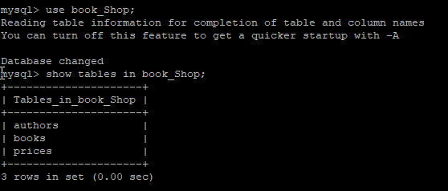

mysql> drop table prices;

Query OK, 0 rows affected (0.03 sec)

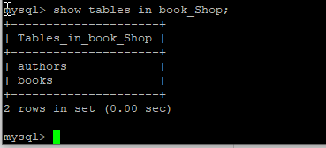

12.Restore your database.

# mysql -uroot -p123QWEasd! book_Shop < book_Shop_backup.sql

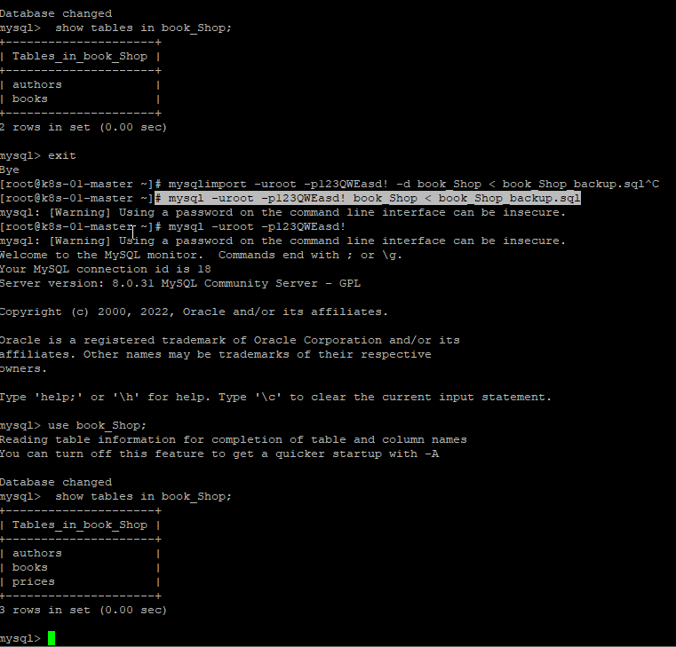

**13.Transfer your local database to RDS AWS**

**In my case AZURE**

**Create Azure Sql DB Server**

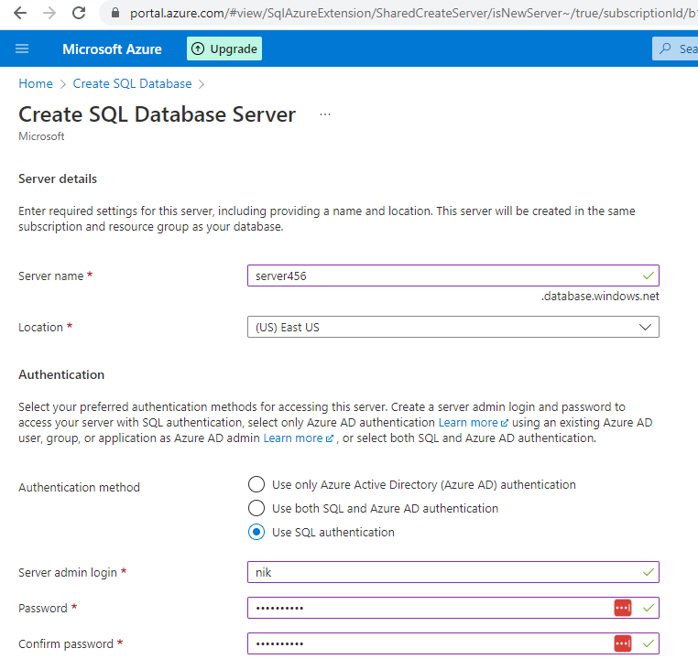

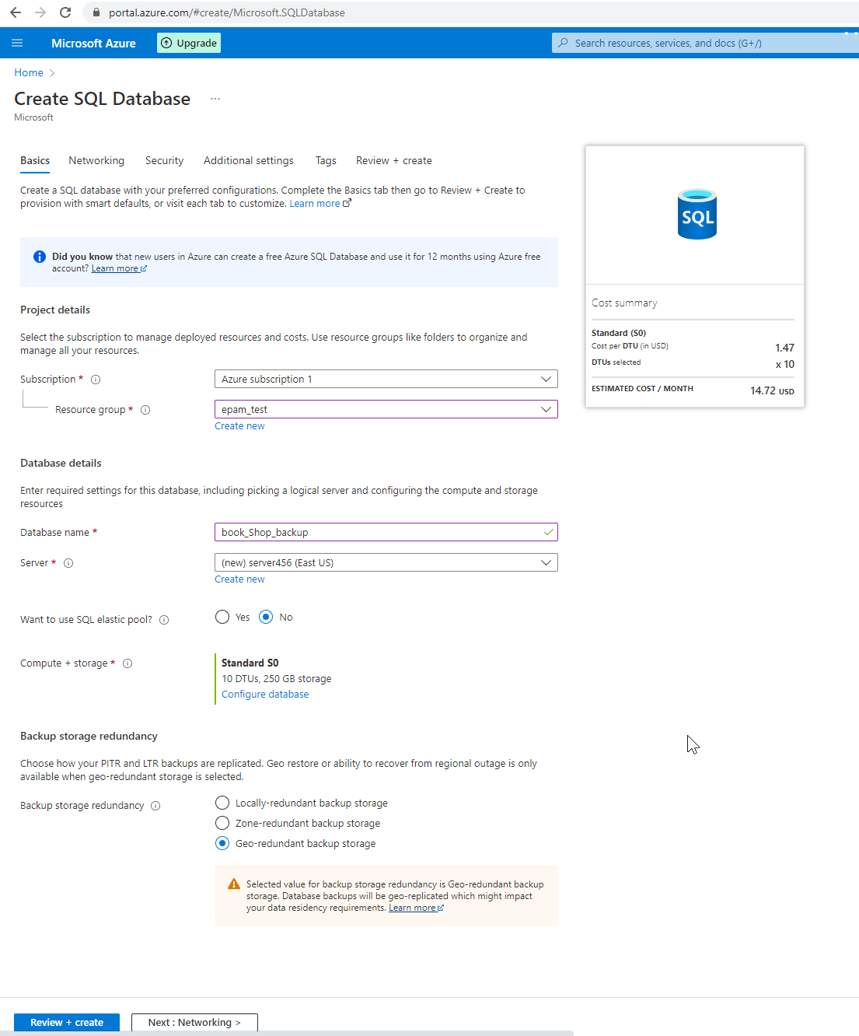

**Connect to your database.**

**I used sql management studio**

**Create tables and fullfill the table**

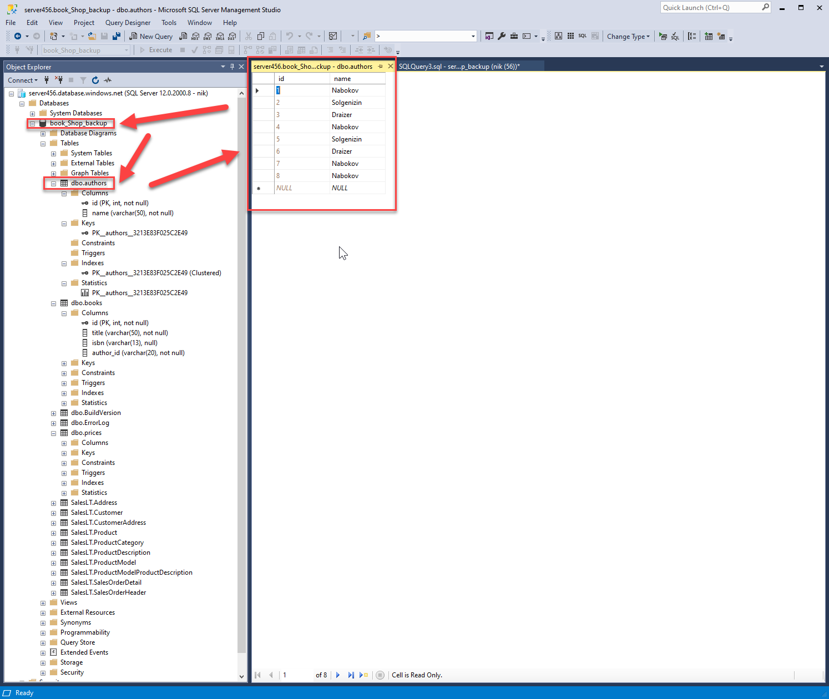

**Have done back up**

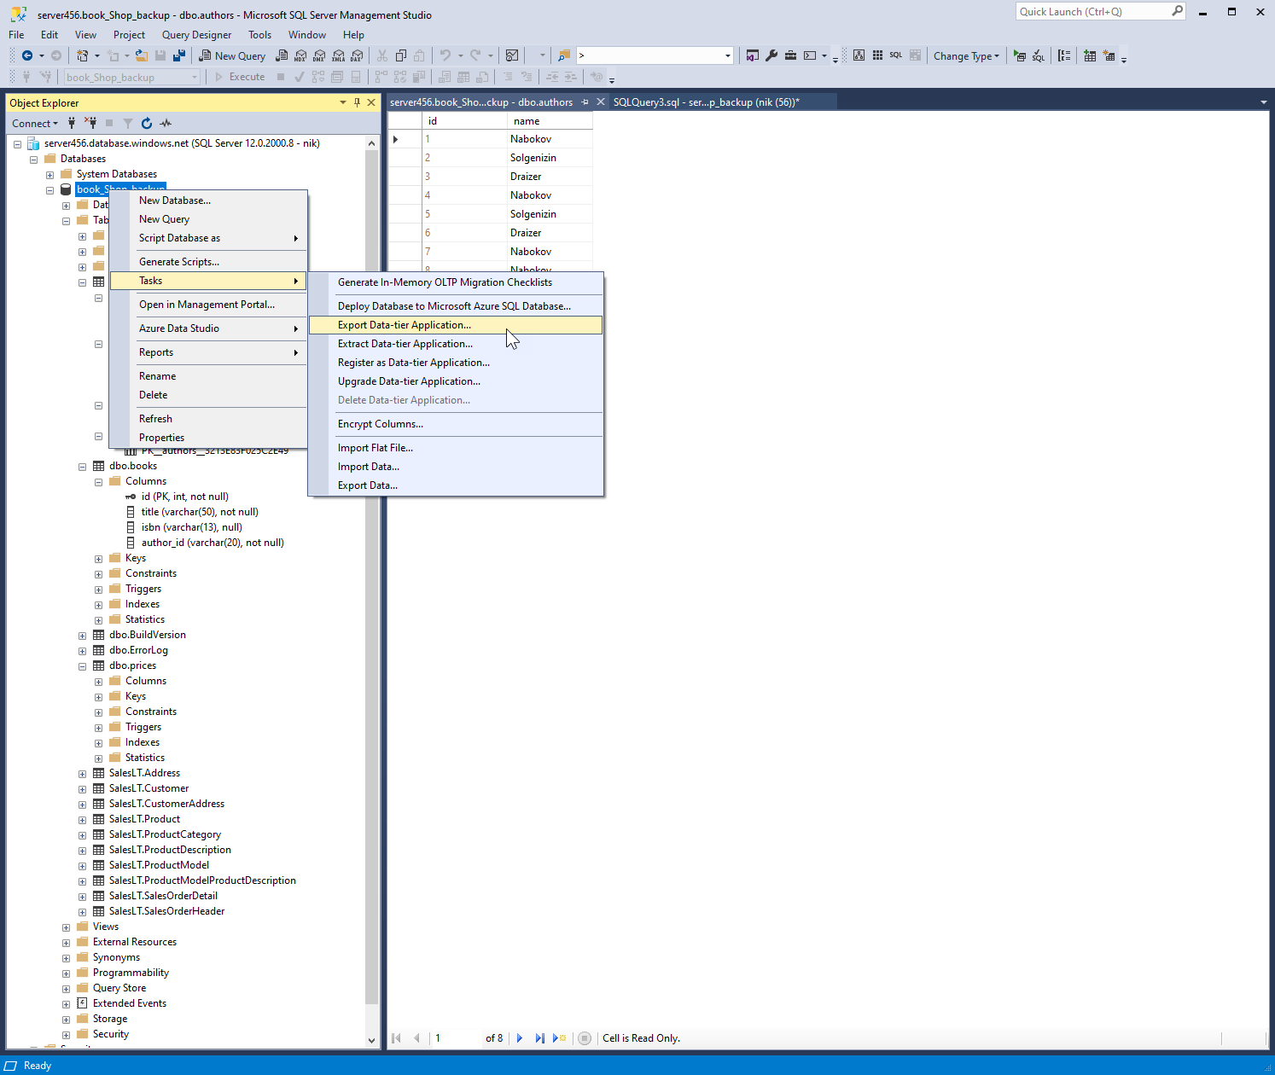

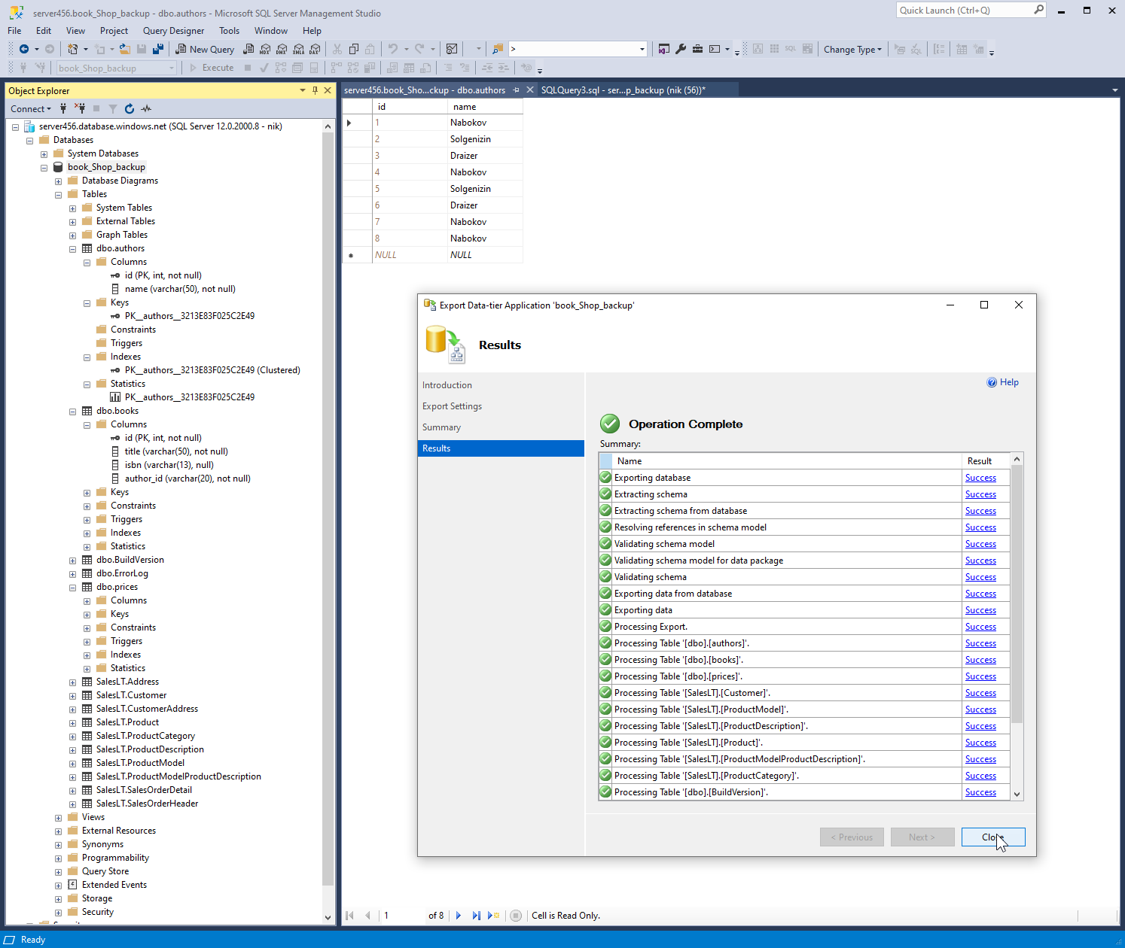

**Delete the table authors**

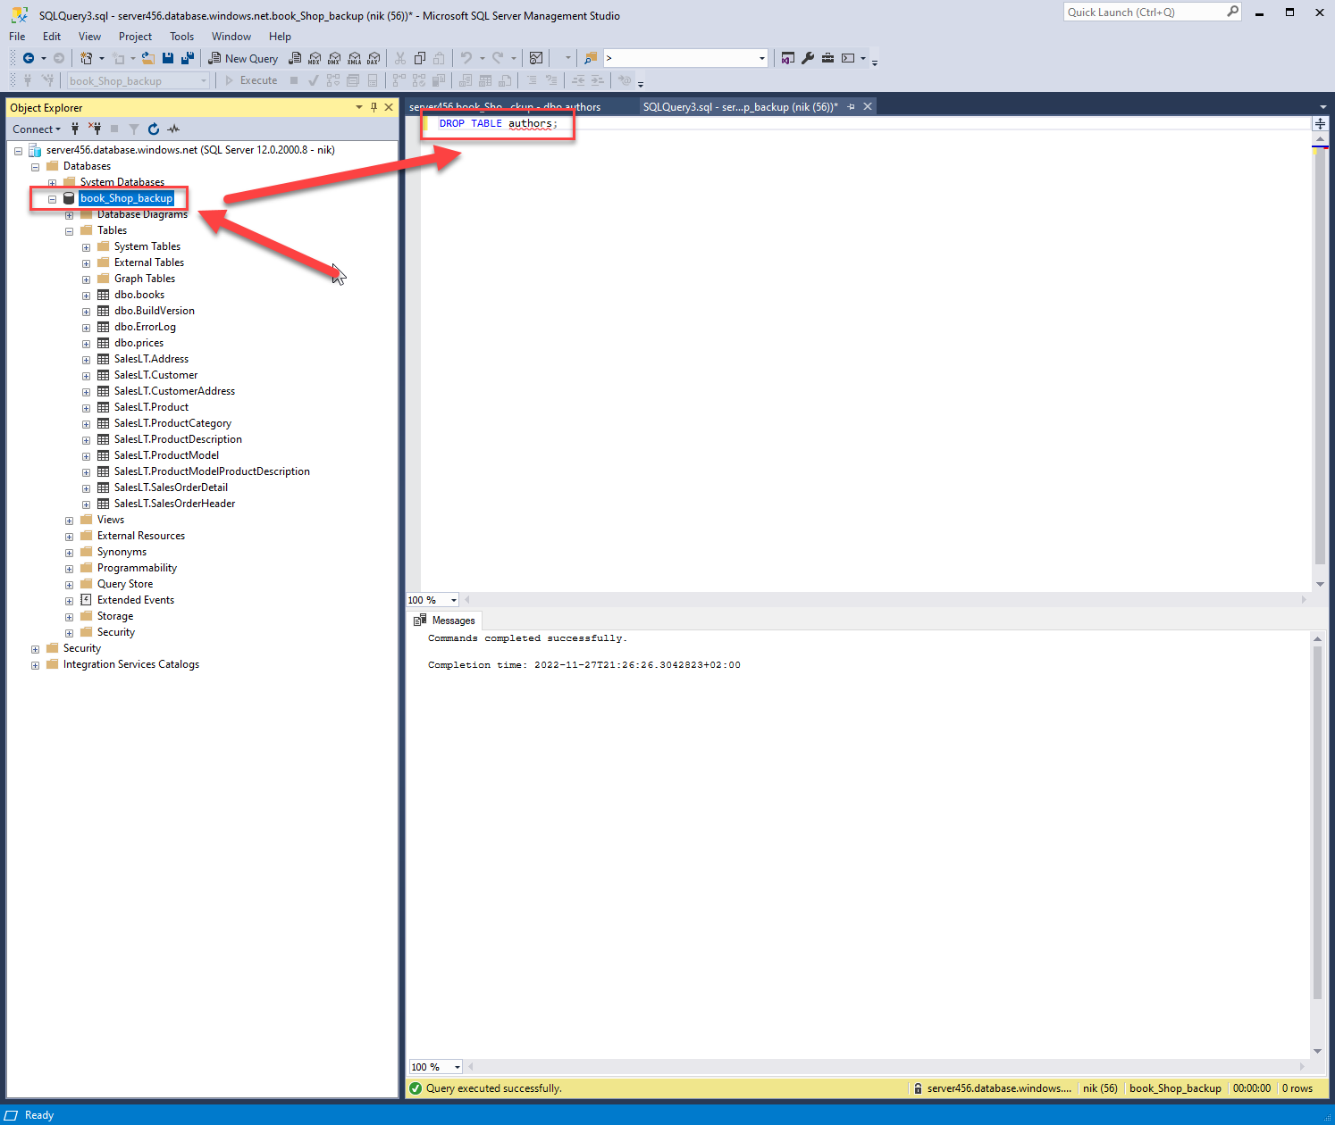

**Restore the Data Base**

